Microlink Group of Companies

CFOS Server Setup

Doc ID: MICROLINK/BPMB0122/SETUP/v1-0

REVISION HISTORY

Ver No. | Date of Release | Prepared By | Reviewed/Approved By | List of Changes from Previous Version
1.0 | 2024-04-11 | Gaozhenyu |  | Initial Creation
1.1

TABLE OF CONTENTS

1 Introduction 4
1.1 Background 4
1.2 Purpose 4
2 Pre-requisites 5
2.1 Prerequisites for installation 5
2.2 Environment and software installation package description 5
3 Setup Description 7
3.1 JDK Setup 7
3.2 Unzip Setup 7
3.3 Redis Setup 8
3.4 Nginx Setup 13
3.5 Database Initialization 15
3.6 Nacos Installation for Registry 17
3.7 Onlyoffice Setup 18
3.8 Deploying Back-end Projects 19
3.9 Deploying Front-end Engineering 21
3.10 Verifying Whether the application is deployed Successfully 21

Introduction

Background
This document is the CFOS Server Setup document for:
Project ID: BPMB0122
Project Name: Implementation of Core banking upgrade
Brief Description of Project: Implementation of Core banking Upgrade existing and new module, Financial Management system, Internet banking and Mobile Banking.

Purpose

Provide deployment instructions for the public credit system service to technical personnel.

Pre-requisites

Prerequisites for installation
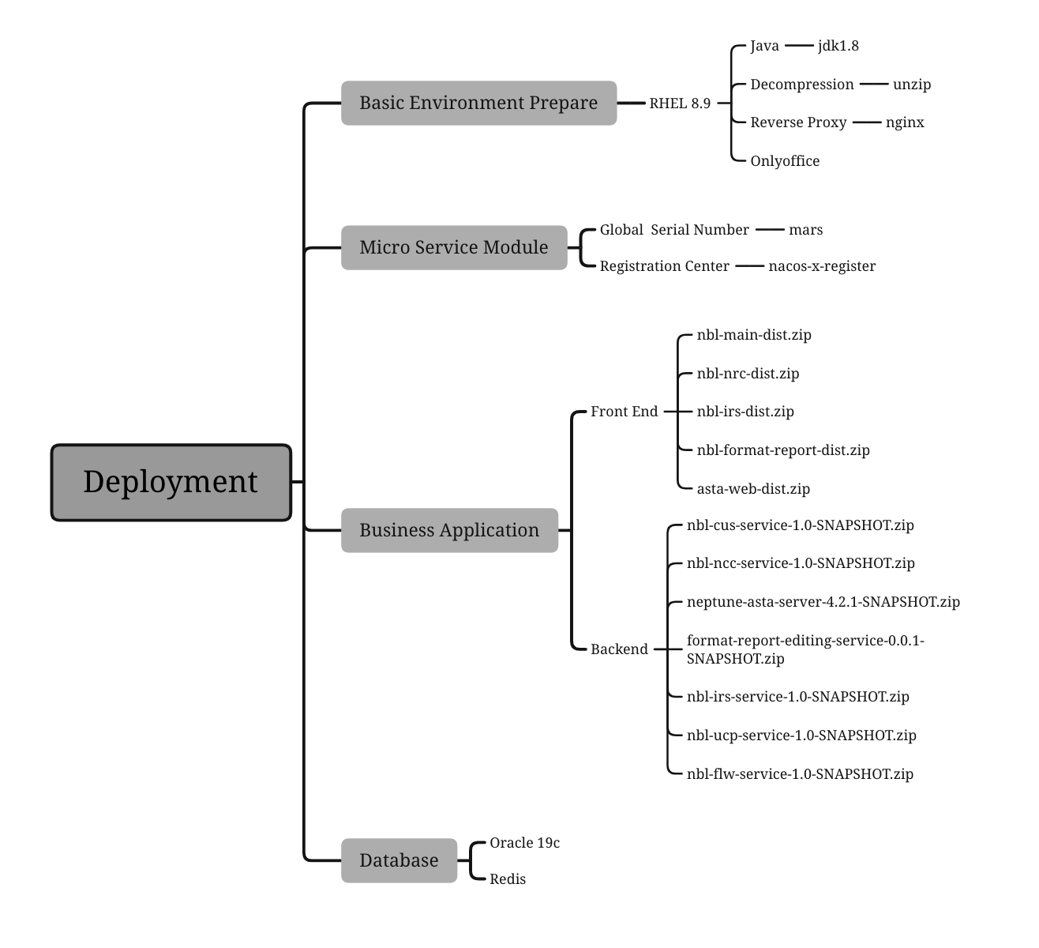

Environment and software installation package description

Environment Description
Deployment Info |  |  |  | Database |  |  | Config
Server | Application/ Middleware | Port | Catalogue | Instance | Username | Password | cpu | Memory(G) | Disk(G)
Server1  （Middleware+Front End）  Linux:RHEL8.9 | nginx+Front Applications | 9100 | /usr/local/nginx/ | / | / | / | 2 | 8 | 50
 | Registry Center | 8848 | /home/galaxy/apps
 | Non-relational database（redis） | 6379 | /usr/local/redis | / | / | /
 | Global Serial Number（mars） | 8082 | /home/galaxy/apps | PDB1 | nblmars | mars123456
Server2  (Application)  Linux: RHEL8.9 | Flow Engine（nbl-flw） | 9201 | /home/galaxy/apps | PDB1 | nblflw | flw123456 | 4 | 16 | 100
 | Rule Engine（asta） | 7000 | /home/galaxy/apps | PDB1 | nblasta | asta123456
 | System Management（nbl-ucp） | 9901 | /home/galaxy/apps | PDB1 | nblsys | sys123456
 | Credit Management（nbl-ncc） | 8001 | /home/galaxy/apps | PDB1 | nblnrc  nblcus | nrc123456  cus123456
 | Formatted Report（nbl-fmr） | 8081 | /home/galaxy/apps | PDB1 | nblfmr | Fmr123456
 | Rating Management（nbl-irs） | 8201 | /home/galaxy/apps | PDB1 | nblirs | irs123456
 | File online editing（docker+onlyoffice） | 6831 | /home/galaxy/apps
Server3（Database）Linux: RHEL8.7 | Oracle |  |  |  |  |  | 4 | 32 | 100

Software Installation package Description
- JDK：jdk-8u321-linux-x64.tar.gz
- Unzip：unzip-6.0-19.el7.x86_64.rpm
- Redis：redis-6.2.14.tar.gz
- Nginx：nginx-1.20.1.tar.gz
- Nacos：nacos-x-register.zip

Setup Description

JDK Setup
Jdk needs to be installed on both servers 1 and 2
Prepare the jdk installation package：jdk-8u321-linux-x64.tar.gz

Uploading the Installation Package
Uploading the Installation Package to the Installation Directory /usr/local

Decompressing the Installation Package
tar -zxvf jdk-8u321-linux-x64.tar.gz

Modifying the Configuration File
vi /etc/profile
Enter the following：
export JAVA_HOME=/usr/local/jdk1.8.0_321
export PATH=$JAVA_HOME/bin:$PATH
export CLASSPATH=.:$JAVA_HOME/lib/dt.jar:$JAVA_HOME/lib/tools.jar

Refreshing the Configuration File
source /etc/profile

Verifying the Installation
java -version
The following information is displayed, indicating that the installation is successful
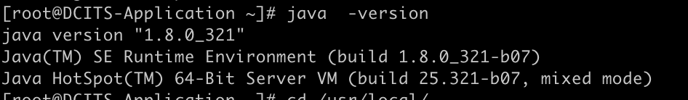

Unzip Setup

Running Installation Commands
dnf install -y unzip

Verifying the Installation
unzip -h
The following information is displayed, indicating that the installation is successful

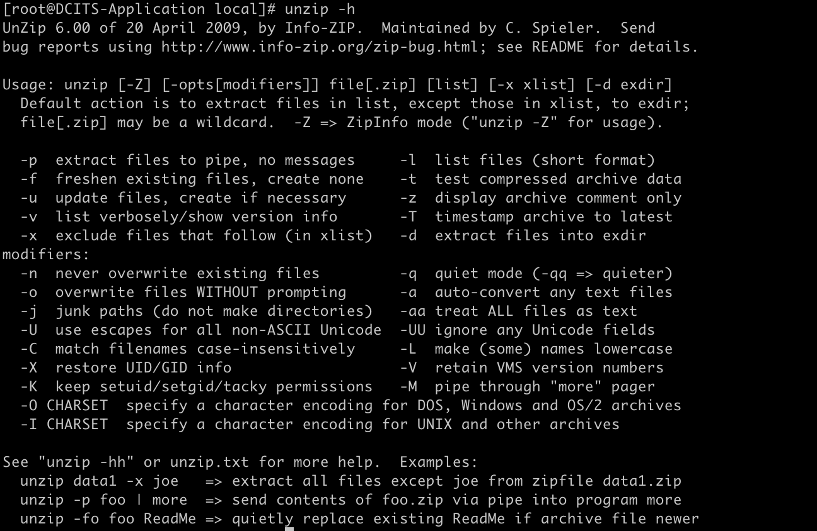

Redis Setup
Prepare the redis installation package:redis-6.2.14.tar.gz

Uploading the Installation Package
Uploading the Installation Package to the Installation Directory /usr/local

Decompressing the Installation Package
tar -zxvf redis-6.2.14.tar.gz

Modifying the Configuration File
vi redis.conf
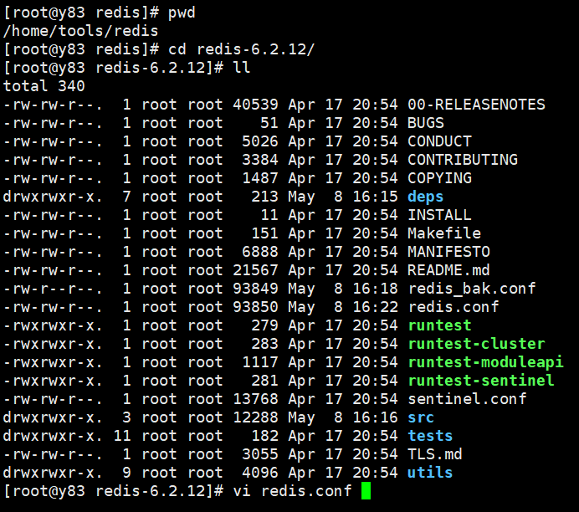
Modify the permission on the redis.conf file
chmod -R 755 redis.conf
Modify the following three contents in the redis.conf configuration file：
1. Line 75
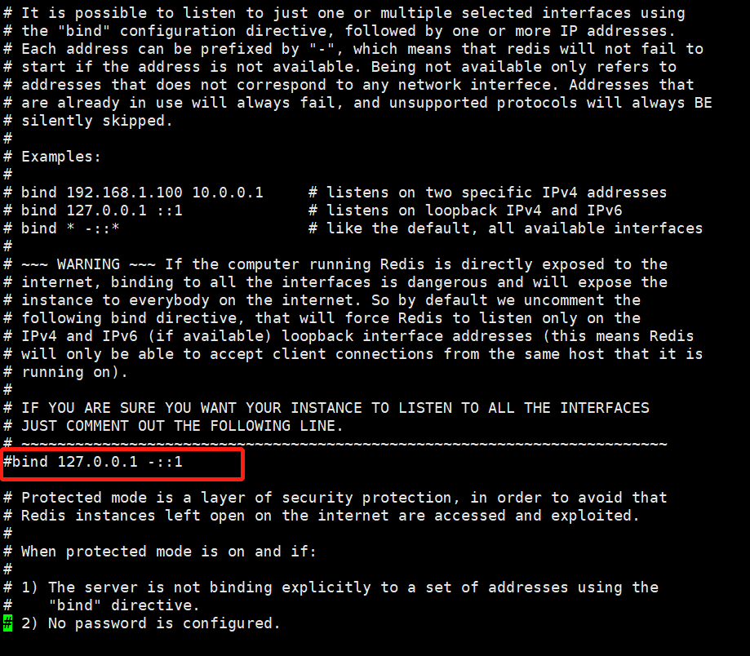
2. Line 94
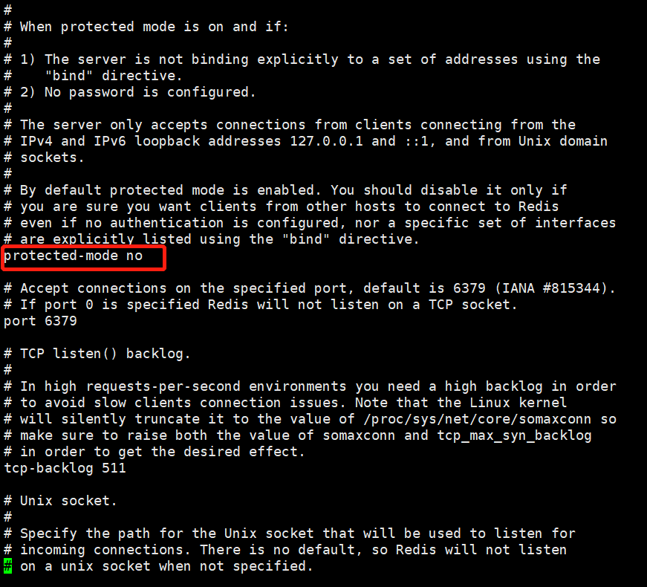
3. Line 259
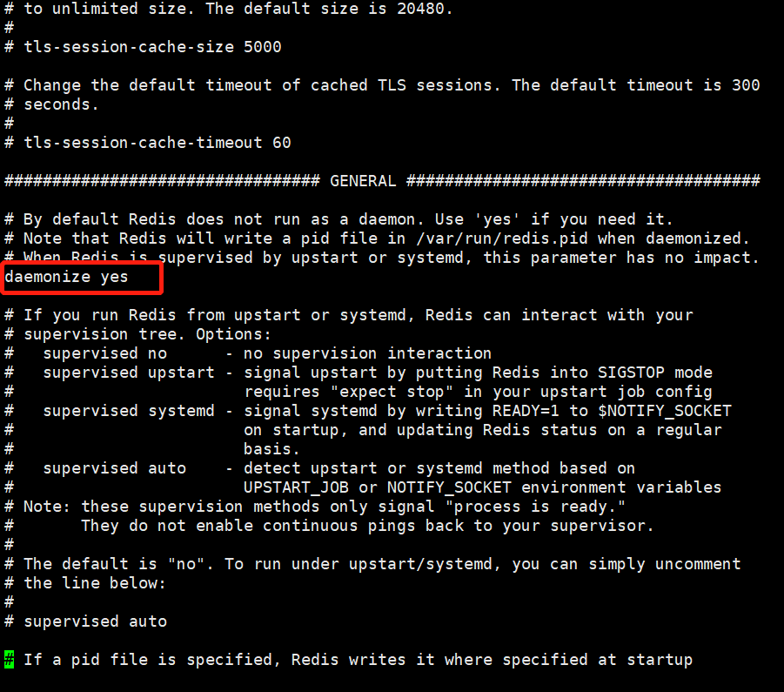

Redis Setup
1. Execute make in the unzip directory
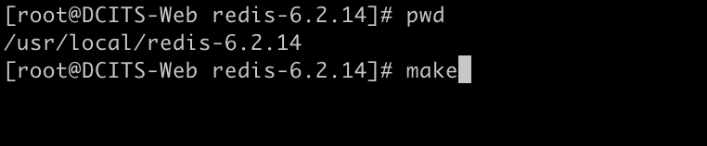
The following result is printed, which is successful
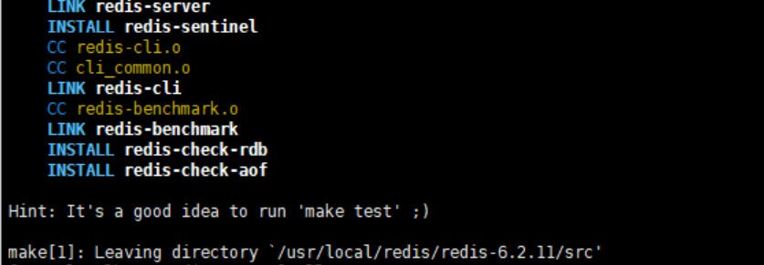
2. make After the command is executed successfully, run make install in the src directory. If the following output is displayed, it is successful
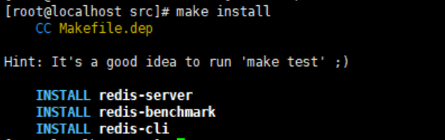

Starting the redis Service
cd /usr/local/redis-6.2.14/src
./redis-server ../redis.conf &

Verifying that the redis Service is started Properly
ps -ef|grep redis
If the following information about redis-server is displayed, it is successful

anzNginx Setup
Prepare the nginx installation Package: nginx-1.20.1.tar.gz

Uploading the Installation Package
Uploading the Installation Package to the Installation Directory /usr/local

Decompressing the Installation Packag
tar -zxvf nginx-1.20.1.tar.gz

Installing Pre Dependency Packages
dnf install -y gcc autoconf automake make pcre pcre-devel zlib zlib-devel

Running the Installation Command
./configure
make
make install

Modifying the Configuration File
cd /usr/local/nginx/conf
vi nginx.conf
Change the monitoring port to 8099
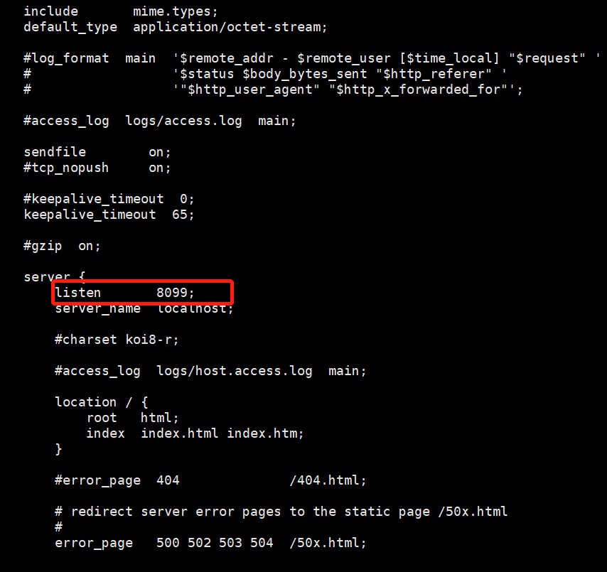

Running the Start Command
cd /usr/local/nginx/sbin
./nginx

Verifying the Installation
Type 172.31.0.50:8099 in your browser
If the following page is displayed, it is a success
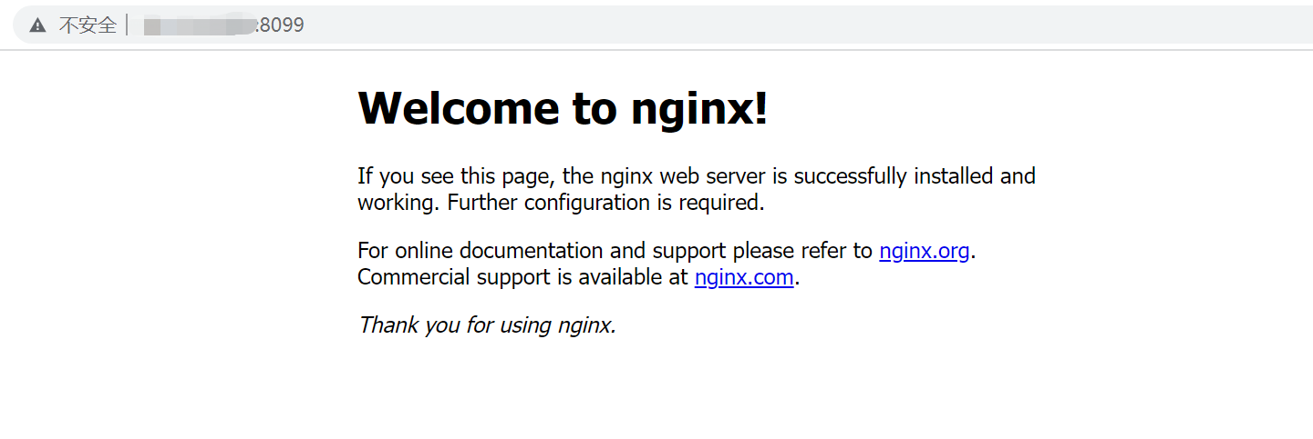

Database Initialization
Prepare the database initialization script, connect to the database using sqlplus /as sysdba, and run the SELECT NAME, OPEN_MODE FROM V$PDBS command. To view the OPEN PDB DATABASE, run ALTER PLUGGABLE DATABASE pdb1 OPEN; alter session set container = PDB1; All of the following are performed under PDB1.

Creating a Database User
create user nblucp identified by ucp123456;
create user nblflw identified by flw123456;
create user nblncc identified by ncc123456;
create user nblcus identified by cus123456;
create user nblirs identified by irs123456;
create user nblfmr identified by fmr123456;
create user nblasta identified by asta123456;
create user nblmars identified by mars123456;

User Authorization
grant connect,resource to nblucp;
grant connect,resource to nblflw;
grant connect,resource to nblncc;
grant connect,resource to nblcus;
grant connect,resource to nblirs;
grant connect,resource to nblfmr;
grant connect,resource to nblasta;
grant connect,resource to nblmars;

Creating Tablespace
Check whether the /u01/app/oracle/oradata directory exists. If no, create a tablespace directory.
CREATE TABLESPACE nbl_data DATAFILE '/u01/app/oracle/oradata/nbldata.dbf' SIZE 200M autoextend on next 200M;
CREATE TABLESPACE nbl_indx DATAFILE '/u01/app/oracle/oradata/nblindx.dbf' SIZE 200M autoextend on next 200M;
CREATE temporary TABLESPACE nbl_temp TEMPFILE '/u01/app/oracle/oradata/nbltemp.dbf' SIZE 200M autoextend on next 200M;

Setting the Default Tablespace
alter user nblucp default tablespace nbl_data;
alter user nblflw default tablespace nbl_data;
alter user nblncc default tablespace nbl_data;
alter user nblcus default tablespace nbl_data;
alter user nblirs default tablespace nbl_data;
alter user nblfmr default tablespace nbl_data;
alter user nblasta default tablespace nbl_data;
alter user nblmars default tablespace nbl_data;

alter user nblucp temporary tablespace nbl_temp;
alter user nblflw temporary tablespace nbl_temp;
alter user nblncc temporary tablespace nbl_temp;
alter user nblcus temporary tablespace nbl_temp;
alter user nblirs temporary tablespace nbl_temp;
alter user nblfmr temporary tablespace nbl_temp;
alter user nblasta temporary tablespace nbl_temp;
alter user nblmars temporary tablespace nbl_temp;

grant unlimited tablespace to nblucp;
grant unlimited tablespace to nblflw;
grant unlimited tablespace to nblncc;
grant unlimited tablespace to nblcus;
grant unlimited tablespace to nblirs;
grant unlimited tablespace to nblfmr;
grant unlimited tablespace to nblasta;
grant unlimited tablespace to nblmars;

Create DIRECTORY
Use the SQL command to create the DIRECTORY.
CREATE DIRECTORY dp_dir AS '/home/oracle';

Grant Access
GRANT READ, WRITE ON DIRECTORY dp_dir TO nblflw;
GRANT READ, WRITE ON DIRECTORY dp_dir TO nblucp;
GRANT READ, WRITE ON DIRECTORY dp_dir TO nblncc;
GRANT READ, WRITE ON DIRECTORY dp_dir TO nblcus;
GRANT READ, WRITE ON DIRECTORY dp_dir TO nblirs;
GRANT READ, WRITE ON DIRECTORY dp_dir TO nblfmr;
GRANT READ, WRITE ON DIRECTORY dp_dir TO nblasta;
GRANT READ, WRITE ON DIRECTORY dp_dir TO nblmars;

Executing the Initialization Script
Upload the dump file to the /home/oracle directory and execute them one by one.
impdp nblflw/flw123456@172.31.0.52:1521/PDB1 DIRECTORY=dp_dir DUMPFILE=nblflw.dmp TABLE_EXISTS_ACTION=replace
impdp nblucp/ucp123456@172.31.0.52:1521/PDB1 DIRECTORY=dp_dir DUMPFILE=nblucp.dmp TABLE_EXISTS_ACTION=replace
impdp nblncc/ncc123456@172.31.0.52:1521/PDB1 DIRECTORY=dp_dir DUMPFILE=nblncc.dmp TABLE_EXISTS_ACTION=replace
impdp nblcus/cus123456@172.31.0.52:1521/PDB1 DIRECTORY=dp_dir DUMPFILE=nblcus.dmp TABLE_EXISTS_ACTION=replace
impdp nblirs/irs123456@172.31.0.52:1521/PDB1 DIRECTORY=dp_dir DUMPFILE=nblirs.dmp TABLE_EXISTS_ACTION=replace
impdp nblfmr/fmr123456@172.31.0.52:1521/PDB1 DIRECTORY=dp_dir DUMPFILE=nblfmr.dmp TABLE_EXISTS_ACTION=replace
impdp nblasta/asta123456@172.31.0.52:1521/PDB1 DIRECTORY=dp_dir DUMPFILE=nblasta.dmp TABLE_EXISTS_ACTION=replace
impdp nblmars/mars123456@172.31.0.52:1521/PDB1 DIRECTORY=dp_dir DUMPFILE=nblmars.dmp TABLE_EXISTS_ACTION=replace

Nacos Installation for Registry
Prepare nacos installation package: nacos-x-register.zip

Uploading the Installation Package
Uploading the Installation Package to the Installation Directory /home/galaxy/apps

Decompressing the Installation Package
unzip nacos-x-register.zip

Executing the Startup Script
cd /home/galaxy/apps/nacos-x-register/bin
./start.sh

Verifying the Installation
Enter the URL in your browser:172.31.0.50:8848/nacos
If the following page is displayed, it is a success
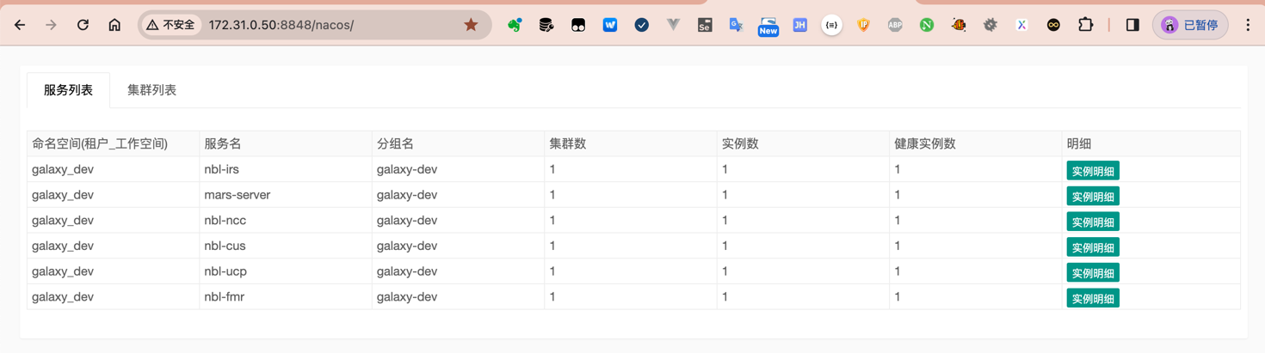
If the access fails, check the firewall：systemctl status firewalld

Onlyoffice Setup
Prepare onlyoffice installation Package dock.zip

Uploading the Installation Package
Uploading the Installation Package to the Installation Directory /home/galaxy/apps

Decompressing the Installation Package
unzip dock.zip

Executing the Startup Script
cd /home/galaxy/apps/dock
./deploy.sh

Verifying the Installation
Enter the URL in your browser:http://172.31.0.51:6831/web-apps/apps/api/documents/api.js
If the following page is displayed, it is a success
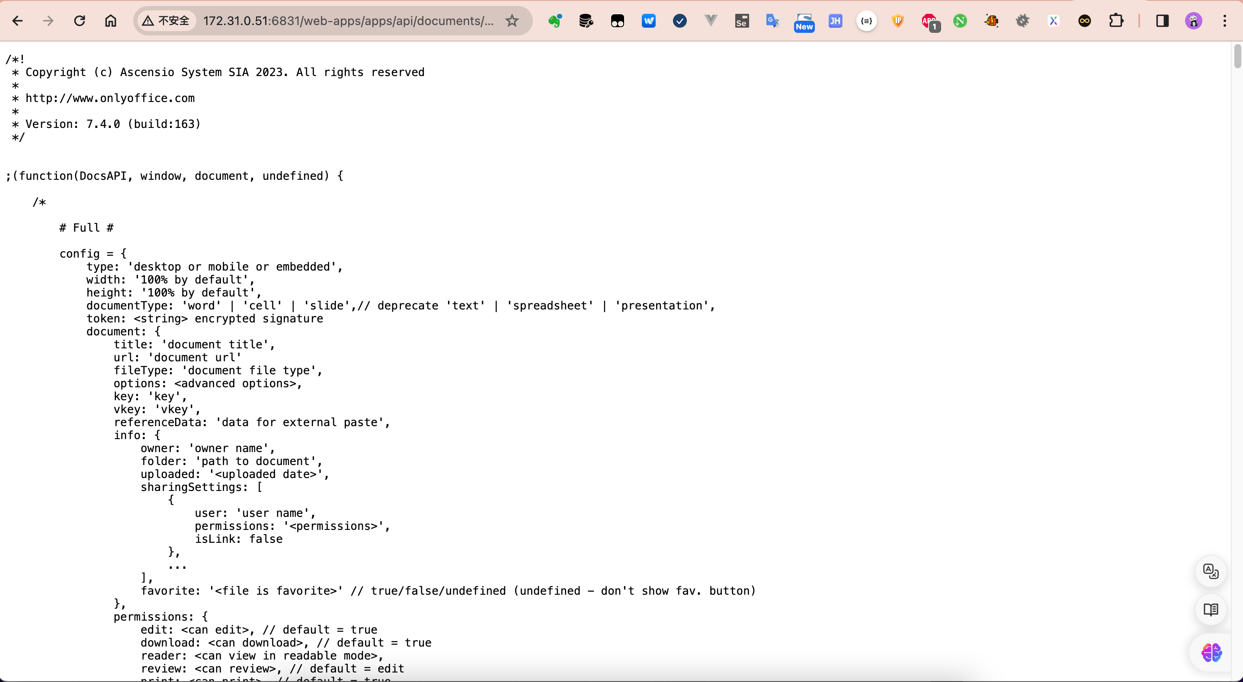

Deploying Back-end Projects

Uploading the Installation Package
Uploading the Installation Package(nbl-cus-service-1.0-SNAPSHOT.zip nbl-ncc-service-1.0-SNAPSHOT.zip、neptune-asta-server-4.2.1-SNAPSHOT.zip、format-report-editing-service-0.0.1-SNAPSHOT.zip 、nbl-irs-service-1.0-SNAPSHOT.zip 、nbl-ucp-service-1.0-SNAPSHOT.zip、nbl-flw-service-1.0-SNAPSHOT.zip) to the Installation Directory /home/galaxy/apps

Decompressing the Installation Package
unzip nbl-flw-service-1.0-SNAPSHOT.zip
unzip nbl-ncc-service-1.0-SNAPSHOT.zip
unzip neptune-asta-server-4.2.1-SNAPSHOT.zip
unzip nbl-cus-service-1.0-SNAPSHOT.zip
unzip nbl-irs-service-1.0-SNAPSHOT.zip
unzip nbl-ucp-service-1.0-SNAPSHOT.zip
unzip format-report-editing-service-0.0.1-SNAPSHOT.zip

Modifying the Configuration File
In the conf directory, modify the contents of the application-dev.yml configuration file
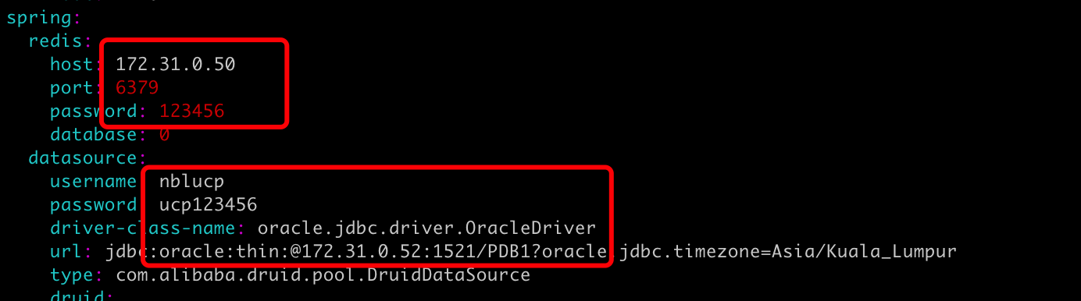
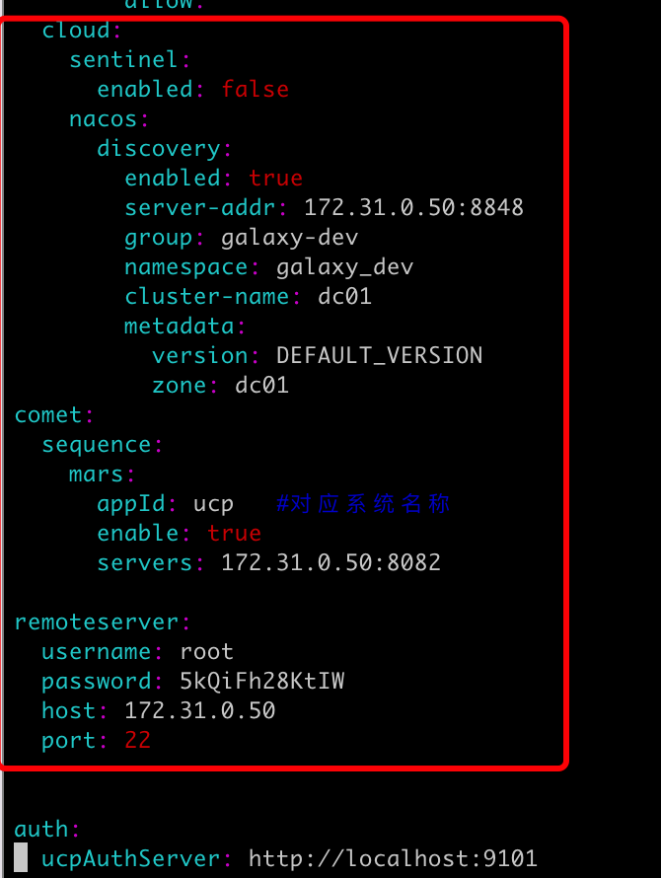

Starting the Back-end Project
./start.sh -p sit
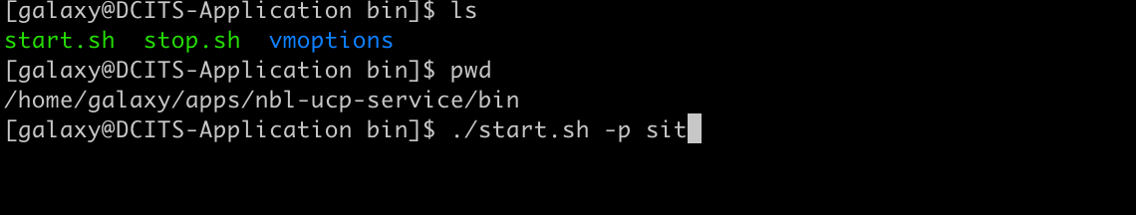

Deploying Front-end Engineering

Uploading the Installation Package
Upload nbl-main-dist.zip, nbl-nrc-dist.zip, nbl-irs-dist.zip, nbl-format-report-dist.zip, asta-web-dist.zip to the html directory in the nginx installation directory
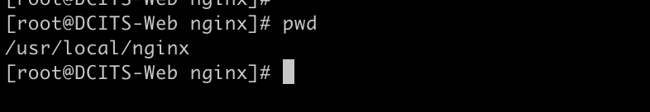

Decompressing the Installation Package
unzip nbl-main-dist.zip
unzip nbl-nrc-dist.zip
unzip nbl-irs-dist.zip
unzip nbl-format-report-dist.zip
unzip asta-web-dist.zip

Modifying nginx Configurations
Modify the nginx.conf configuration file in the nginx conf directory and add the following:

Restarting the nginx Service
Run the startup script in the sbin directory under the nginx installation directory
./nginx

Verifying Whether the application is deployed Successfully
Type the URL into your browser：172.31.0.50:9100
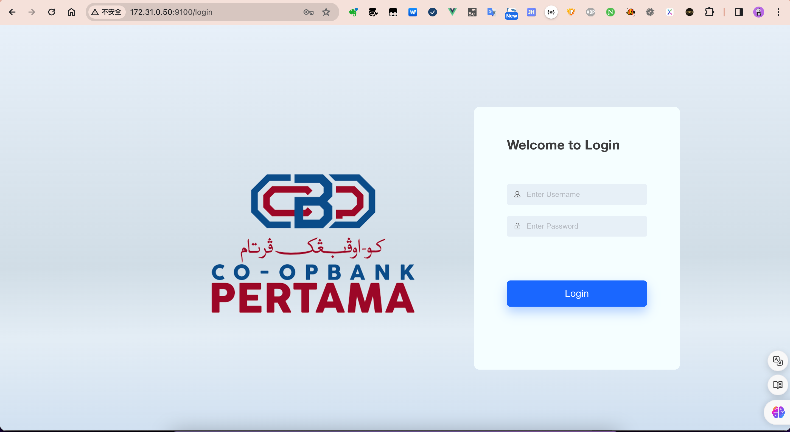
Username/Password：ucp/qwe123

-----------------------------------------
End of Document

